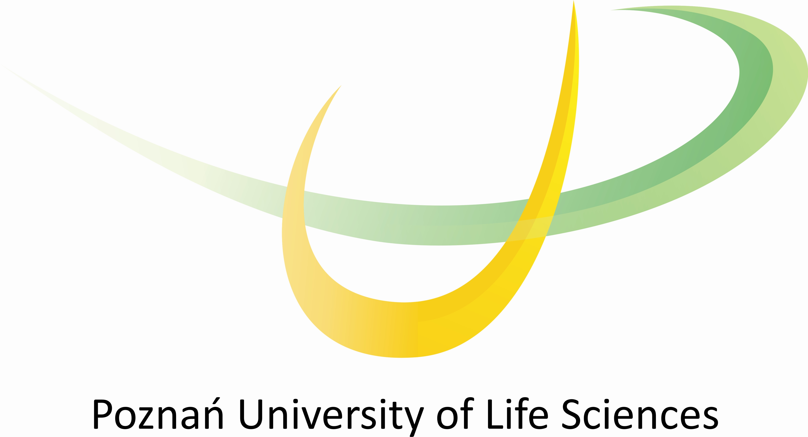

Official Name of Institution | UNIWERSYTET PRZYRODNICZY W POZNANIU  Poznań University of Life Sciences
Erasmus Code | PL POZNAN04
Street Address | ul. Wojska Polskiego 28  60-637 Poznań  Poland
Rector/Head of Institution | Prof. dr hab. Grzegorz Skrzypczak
Bilateral Agreements - signature | Vice Rector for Science and International Relations:  Prof. dr hab. Jan Pikul
Authorized Erasmus+ Institutional  Co-ordinator  phone  fax  e-mail | Prof. dr hab. Włodzimierz Nowak  +48 61 8487235  +48 61 8487012  nowakwl@jay.up.poznan.pl
Office of International Relations  official name of office,  address  phone  fax  Head of Office:  ERASMUS+ team:  Is accommodation available  for Erasmus+ students?  Accommodation Responsible: | International Relations Office  ul. Wojska Polskiego 28  60-637 Poznań, Poland  +48 61 8487012, 61 8487014  +48 61 8487012  mgr Lidia Huchwajda  tel.+48 61 8487012, lidkah@up.poznan.pl  mgr Joanna Pietrzak : Bilateral agreements  Outgoing and incoming Teachers  Outgoing Students - study and placements  Tel. +48 61 848 7012 fax +48 61 848 7012 joamar@up.poznan.pl  mgr Aneta Dach: Incoming Students – study and placements  Accommodation  Tel. +48 61 848 7012 fax +48 61 848 7012 netka@up.poznan.pl  YES – Students Hall of Residence  ul. Piątkowska 94/ 3C, Poznań, Poland  +48 61 8466486, fax +48 61 8204693  mgr Aneta Dach netka@up.poznan.pl
Internet Address | www.puls.edu.pl
Homepage for Incoming Students | www.erasmusplus.up.poznan.pl
Academic Calendar | Autumn/Winter semester 2014/2015  Teaching classes (15 weeks): 29.09.2014. - 02.02.2015  Christmas break: 22.12.2014 - 06.01.2015  Winter examination session: 03.02.2015 - 15.02.2015  Break : 16.02.2015 - 26.02.2015  Spring/Summer semester 2014/2015  Teaching classes (15 weeks): 02.03.2015 - 23.06.2015  Easter break: 02.04.2015- 07.04.2015  Summer examination session: 24.06.2015- 05.07.2015  FREE DAYS (no classes) :  2 October 2014 inauguration of the academic year  31 October 2014  02 November 2014  10 November 2014  02 May 2014  05 May 2014  National Holiday and University free days (University is closed)  01 Novemver 2014  11 November 2014  01 January 2015  06 January 2015  01 May 2015  19 June 2015  15 August 2015
Nomination of Erasmus+ Students should be sent to: | Aneta Dach, IRO netka@up.poznan.pl
Forms necessary for acceptance | Learning Agreement  Transcript of Records  Accommodation Form
Deadlines for applicants | ON-LINE registration www.erasmusplus.up.poznan.pl/en and after forms should be send to IRO:  For WINTER semester: 31 of May  For SUMMER semester: 30 of November
Educational language/s for foreign students | English
Any conditions for students nominated for the study stay? | Proof on English knowledge - level B2
Any conditions for the selection of the courses? | Particular module runs if there will be 5 students (minimum) who choose same module. Students must choose whole module not particular course.

FACULTY ERASMUS+ COORDINATORS:

Faculty | COORDINATOR | E-mail | Phone
Agronomy and Bioengineering | prof. dr hab. Andrzej Wojciechowski | ajwoj@up.poznan.pl | +48 61 8487760
Forestry | dr inż. Tomasz Najgrakowski | dentomn@up.poznan.pl | +48 61 8487658
Horticulture and Landscape Architecture | dr hab. Maria Morozowska | mariamor@up.poznan.pl | +48 61 8487700
Wood Technology | dr hab. Magdalena Zborowska | mzbor@up.poznan.pl | +48 61 8487462
Food Science and Nutrition | prof. dr hab. Zbigniew Krejpcio | zkre@up.poznan.pl | +48 61 8487336
Animal Breeding and Biology | prof.dr hab. Włodzimierz Nowak | nowakwl@jay.up.poznan.pl | +48 61 8487235
Land Reclamation and Environmental Engineering | prof. dr hab. Krzysztof Szoszkiewicz | kszoszk@up.poznan.pl | +48 61 8466520
Economics and Social Sciences | dr Izabela Lipińska | lipinska@up.poznan.pl | +48 61 8466102

